We supply IT, Hardware, Software Solutions and Professional Services with support from Global Partners*.*

Our Partners

(Under the title, there would be logos of partner companies. Links would be attached to the logos redirecting to their official websites)

Our Services

[**Supply IT Products**](https://shaifurrahmanshawon.github.io/FSC/code/)

We supply **Fingerprint Readers, Iris Scanners, Access Control Systems** as well as **Security, Biometrics and Access Management Solutions** to some of the most renowned business identities of our country with the help of our trusted global partners.

#### [Design reporting models](https://shaifurrahmanshawon.github.io/FSC/code/)

We design **MIS reporting models compatible with internal ERPs (i.e. SAP)** for large Manufacturing, Distribution, Sales and Marketing organizations to help upper management make faster business decisions.

#### [Prepare Investment Proposals](https://shaifurrahmanshawon.github.io/FSC/code/)

We assess business feasibility for medium to large scale investments through **Sensitivity Analysis, IRR, NPV, Payback, EBIDA, ROCE and PPT for Board and Bank Loan approvals.**

#### 

#### Risk Analysis

We **review Company Balance Sheets**, Profit Margins as well as Short Term Business Plans to identify potential Risks, and suggest action plans for the mitigation of major risks.

#### [Professional Services](https://shaifurrahmanshawon.github.io/FSC/code/)

We help locally and internationally funded companies set up businesses in Bangladesh by obtaining necessary approvals from regulatory bodies such as **RJSC, NBR, BIDA** through our network and collaborations.

#### [Business Restructuring Proposals](https://shaifurrahmanshawon.github.io/FSC/code/)

We conduct **Profitability analysis for business restructuring** and help carry out Legal Entity closures by following through with required Legal and Statutory steps and compliances.

Our Team

(There would be separate sections, one for team lead, some for other officials).

Completed MBA (Finance) in 1987 from IBA, University of Dhaka, Bangladesh.

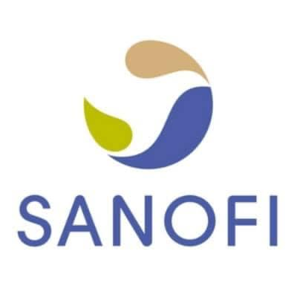

Started career with Sanofi Bangladesh (ex-Fisons Pharmaceuticals), played several critical roles under Regional Sales & Distribution and Financial Planning & Control department till Mar 1997.

Worked with Linde Bangladesh (ex-BOC) in different strategic roles as Head of Planning & Control, Head of Strategic Marketing & Planning as Level 3 Manager (General Manager). Also contributed as a member of Senior Leadership Team, Business Council, Wages Negotiation Committee, Pricing Committee, Safety Council, Trade Working Capital Monitoring and Cost Control Team till Dec 2008.

Joined Nokia Networks (ex-NSN) as CFO & Country Controller and Chair the Board till Dec 2017. Lead Nokia Bangladesh Leadership Team and represented Nokia in FICCI, Govt. Regulatory Bodies and Different Industry Leaders Forum.



Joined GSK for a very Strategic Role as Advisor and Head of Govt Affairs, also performed the responsibility of Company Secretary and supported the Board till closures of GSK Bangladesh Business in 2020.



Worked as CEO with TigerIT country’s largest software development company till Aug 2023. Lead the Leadership Team, reformed Finance, HR, SCM, Legal and Operations team, served govt. customers like BEC, DIP, BRTA and BMTF and many large overseas and local private customers.



From Sep 2023….

Started this new journey in Sep 2023 with FSC as founder CEO with an objective to explore the opportunities of sharing business acumen as a consultant also to supply IT Hardware & Software Solutions locally and abroad.